**Name ______________________________ Miami e-mail:** [**__________________@miamioh.edu**](mailto:__________________@miamioh.edu)

1. Fill in the array below to represent this minheap:

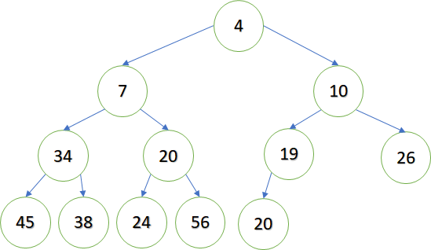

|  |  |  |  |  |  |  |  |  |  |  |  |  |  |  |  |  |  |  |  |
| --- | --- | --- | --- | --- | --- | --- | --- | --- | --- | --- | --- | --- | --- | --- | --- | --- | --- | --- | --- |
| **0** | **1** | **2** | **3** | **4** | **5** | **6** | **7** | **8** | **9** | **10** | **11** | **12** | **13** | **14** | **15** | **16** | **17** | **18** | **19** |
|  |  |  |  |  |  |  |  |  |  |  |  |  |  |  |  |  |  |  |  |

1. In general, the children of node 23 in a minheap are: node _____ and node _____.
2. In general, the parent of node 23 is node _____.
3. Show how the minheap will change after adding the value 9:



1. Using the array, show how the minheap will change after adding the value 9:

|  |  |  |  |  |  |  |  |  |  |  |  |  |  |  |  |  |  |  |  |
| --- | --- | --- | --- | --- | --- | --- | --- | --- | --- | --- | --- | --- | --- | --- | --- | --- | --- | --- | --- |
| **0** | **1** | **2** | **3** | **4** | **5** | **6** | **7** | **8** | **9** | **10** | **11** | **12** | **13** | **14** | **15** | **16** | **17** | **18** | **19** |
|  |  |  |  |  |  |  |  |  |  |  |  |  |  |  |  |  |  |  |  |

1. Show how the minheap will change after adding the value 28. Then add the value 1. Then add the value 2.

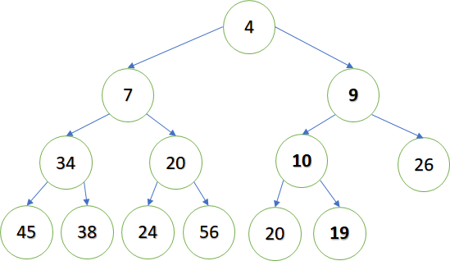

1. Here is an array representing a minheap. Show how the array will change after adding the value 8.

|  |  |  |  |  |  |  |  |  |  |  |  |  |  |
| --- | --- | --- | --- | --- | --- | --- | --- | --- | --- | --- | --- | --- | --- |
| **0** | **1** | **2** | **3** | **4** | **5** | **6** | **7** | **8** | **9** | **10** | **11** | **12** | **13** |
|  | 5 | 14 | 23 | 32 | 41 | 87 | 90 | 50 | 64 | 53 |  |  |  |

1. Here is a minheap. Remove the min value. Show the changes in the tree and in the array.

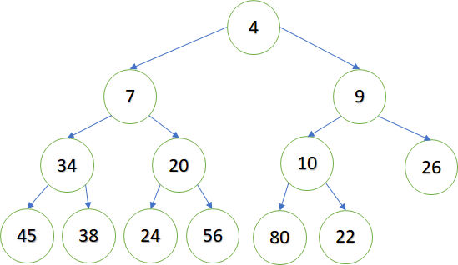

|  |  |  |  |  |  |  |  |  |  |  |  |  |  |  |  |
| --- | --- | --- | --- | --- | --- | --- | --- | --- | --- | --- | --- | --- | --- | --- | --- |
| **0** | **1** | **2** | **3** | **4** | **5** | **6** | **7** | **8** | **9** | **10** | **11** | **12** | **13** | **14** | **15** |
|  | 4 | 7 | 9 | 34 | 20 | 10 | 26 | 45 | 38 | 24 | 56 | 80 | 22 |  |  |

1. Here is a minheap. Remove the min value. Show the changes in the tree and in the array.

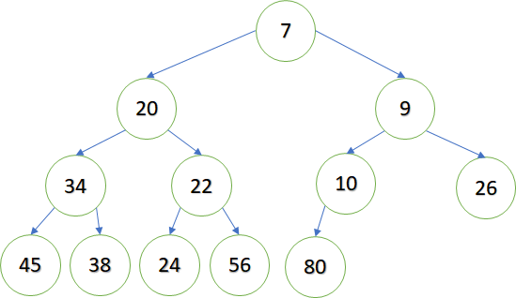

|  |  |  |  |  |  |  |  |  |  |  |  |  |  |  |  |
| --- | --- | --- | --- | --- | --- | --- | --- | --- | --- | --- | --- | --- | --- | --- | --- |
| **0** | **1** | **2** | **3** | **4** | **5** | **6** | **7** | **8** | **9** | **10** | **11** | **12** | **13** | **14** | **15** |
|  | 7 | 20 | 9 | 34 | 22 | 10 | 26 | 45 | 38 | 24 | 56 | 80 |  |  |  |

1. Here is an array representation of a minheap. Show the changes after removing the min value.

|  |  |  |  |  |  |  |  |  |  |  |  |  |  |
| --- | --- | --- | --- | --- | --- | --- | --- | --- | --- | --- | --- | --- | --- |
| **0** | **1** | **2** | **3** | **4** | **5** | **6** | **7** | **8** | **9** | **10** | **11** | **12** | **13** |
|  | 5 | 23 | 14 | 87 | 90 | 32 | 41 | 90 | 94 | 100 |  |  |  |